LAB REPORT NO 12
ROTS (Real-Time Operating System)



Spring 2026
CSE-420L Embedded Systems LAB

Submitted By: Naveed Ahmad
Registration No: 22PWCSE2165
Section: B

“On my honor, as student of University of Engineering and Technology, I have neither given nor received unauthorized assistance on this academic work”

Submitted to:
Engr. Muhammad Shahzad
June 25, 2026

Department of Computer Systems Engineering
University of Engineering and Technology Peshawar

Title: ROTS (Real-Time Operating System)

Objectives
The objective of this lab was to understand the basic concepts of Real-Time Operating Systems (RTOS) and implement multitasking using FreeRTOS on embedded systems. The lab focused on task creation, task scheduling, multitasking, LED control, serial communication, and task priority handling.

Apparatus:
- ESP32 Board
- LEDs
- Resistors
- Jumper Wires
- Breadboard
- USB Cable
- Wokwi software
- Arduino IDE with FreeRTOS Library

Lecture:
Real time operating systems An Operating system designed to execute tasks with precise timing constraints.
Unlike windows/ Linux focus on user experience.
RTOS focuses on deterministic timing.

RTOS Ensure:
  - Fast Response
  - Predicted execution
  - Task prioritization
  - Multitasking

Types:
- Hard Real-time
Missing deadline = system failure
Ex:
  - Aircraft control
  - Medical device
  - Missile system

- Soft Real-time
Missing deadline reduces performance but system still works.
EX:
- Video streaming
- Gaming
- Drone telemetry display
Problems:
- No priority handling.
- Blocking delays stops.
- Difficult to scale
- Timing become

ROTS Solves this by
- Resuming multiple tasks independently
- Scheduling tasks efficiently
- Managing priorities
- Reducing CPU wastage

RTOS Concepts:
Tasks: A small independent program
Ex:
- LED blinking
- Sensor Reading
- UART Communication
- Motor Control

Schedules:
- Decides which task runs
- When it runs.
- For how long
Priority:
Higher priority tasks run before low priority tasks.
Ex:
Emerging stop button High priority.
LCD update Low priority
Context switching:
RTOS saves the state of one task and switched to another.
- Register
- Program counter
- Stack pointer
Free RTOS Most common in embedded system
Zephyr IOT Application
RTX Arm Complex System
VxWorks Aerospace and defense
RTEMS Space System

Free RTOS Basics:
Components
Tasks: Impendent functions executed by scheduler
Queues: Used for task communication
Semaphores: Used for synchronization
Timers: Execute functions periodically

Tasks States:
Running: Currently executing
Ready: Waiting for CPU
Blocked: Waiting for event or delay
Suspended: Temporary stopped

Theory
A Real-Time Operating System (RTOS) is an operating system designed to perform tasks within a specific time limit. Unlike normal operating systems that focus on user experience, RTOS focuses on fast and predictable task execution.
RTOS provides:
- Fast response time
- Multitasking
- Task scheduling
- Task prioritization
- Efficient CPU usage
In FreeRTOS, tasks run independently and the scheduler decides which task should execute according to its priority. Higher priority tasks execute before lower priority tasks. RTOS also supports context switching, where the CPU switches from one task to another efficiently.
Main RTOS Components:
- Tasks
- Queues
- Semaphores
- Timers

Task01:
Basic RTOS Program 2 –task running independently
Concept:
Task1: Led blinking
Task2: Print message on serial Monitor.

- XtaskCraete(
TasksFunction, )

Procedure:
- Connect the circuit properly.
- Open Arduino IDE.
- Write and upload the code.
- Open Serial Monitor.
- Observe LED blinking and serial messages simultaneously.

Code:
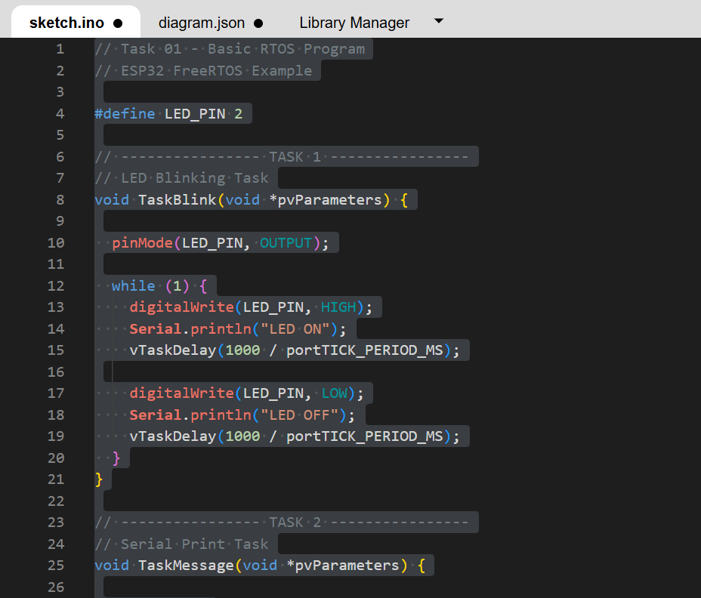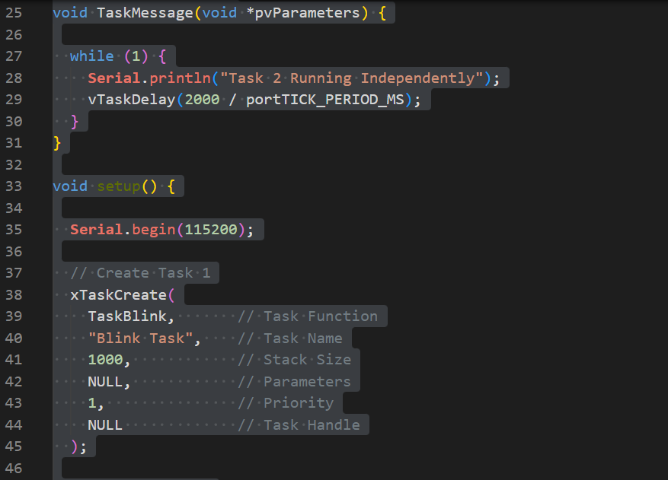

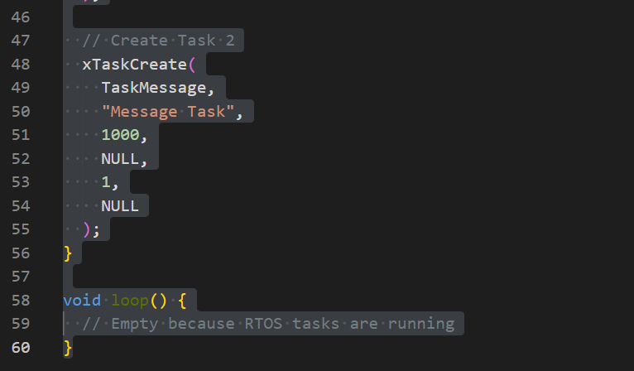

Connections:
- Connect one LED to a digital output pin through a resistor.
- Connect the board to the computer using a USB cable.
- Open Serial Monitor for message display.

Circuit Diagram and Output:
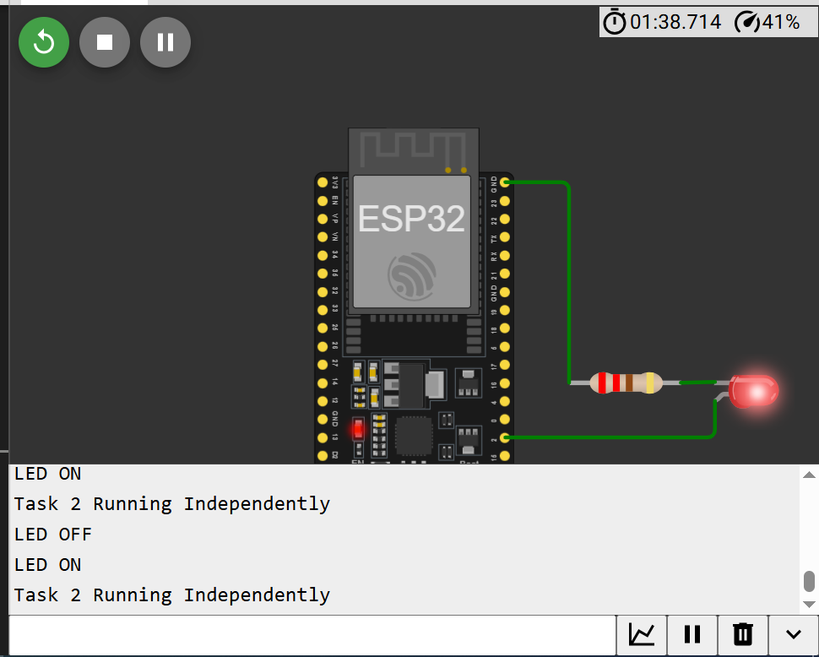

Algorithm:
- Start the program.
- Create Task 1 for LED blinking.
- Create Task 2 for printing messages on Serial Monitor.
- Start the scheduler.
- Both tasks run independently in parallel.

Result:
The LED blinked continuously while messages were printed on the Serial Monitor at the same time. This showed successful multitasking using RTOS.
------------------------------------------------------------------------
Task 02:
Dual LED Control Create 2 tasks
1 Control LED1 (500 ms)
2nd Control LED2 (1000 ms)

Tasks Priority:
xTaskCreate(Task1, “low”, 1000, Null, 1, Null)
xTaskCreate(Task2, “High”, 1000, Null, 3, Null)

Procedure:
- Make the LED connections on breadboard.
- Open Arduino IDE and write the program.
- Upload the code to the board.
- Observe the blinking pattern of both LEDs.
Code:
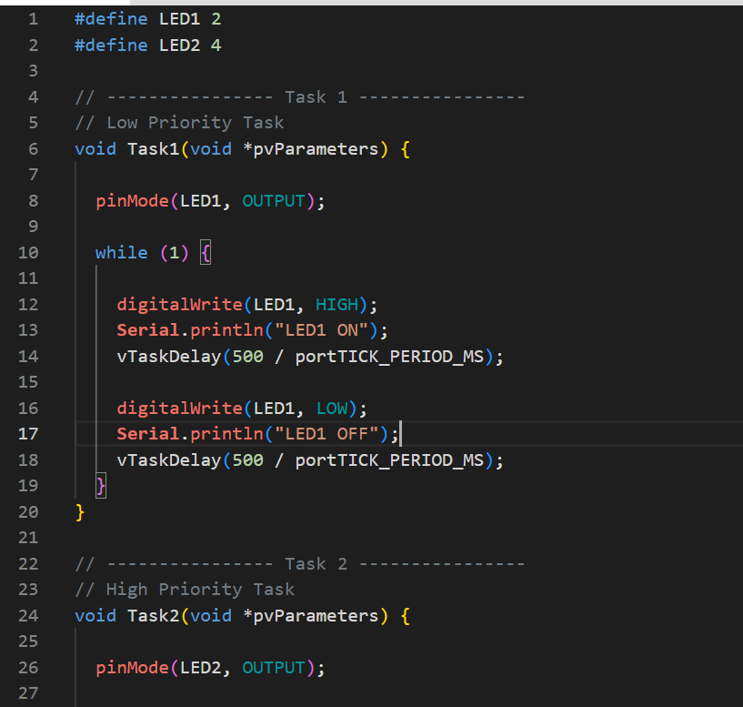
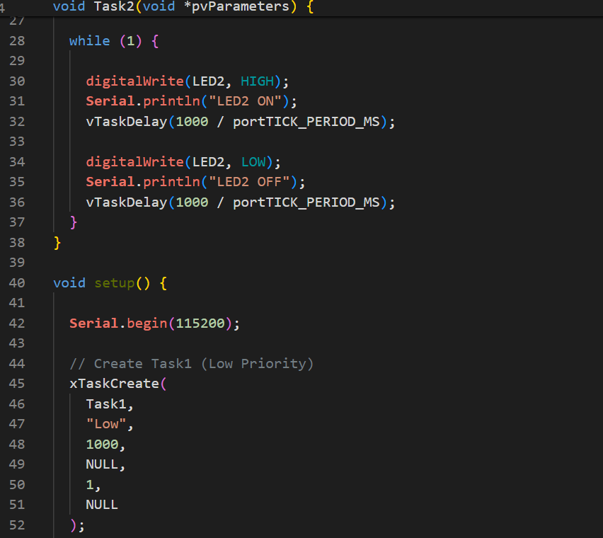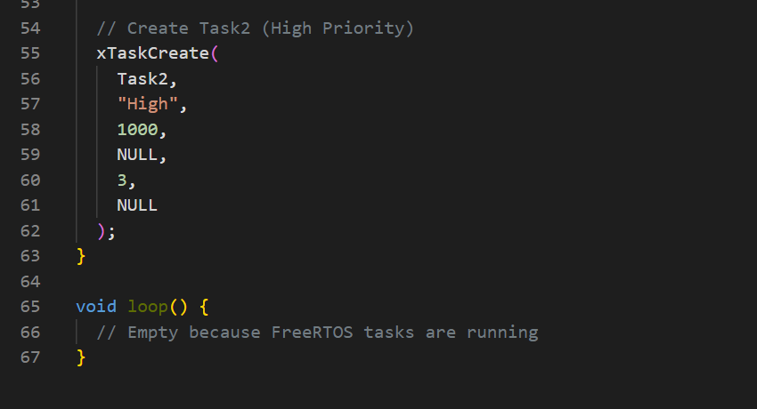

Circuit diagram and Output:
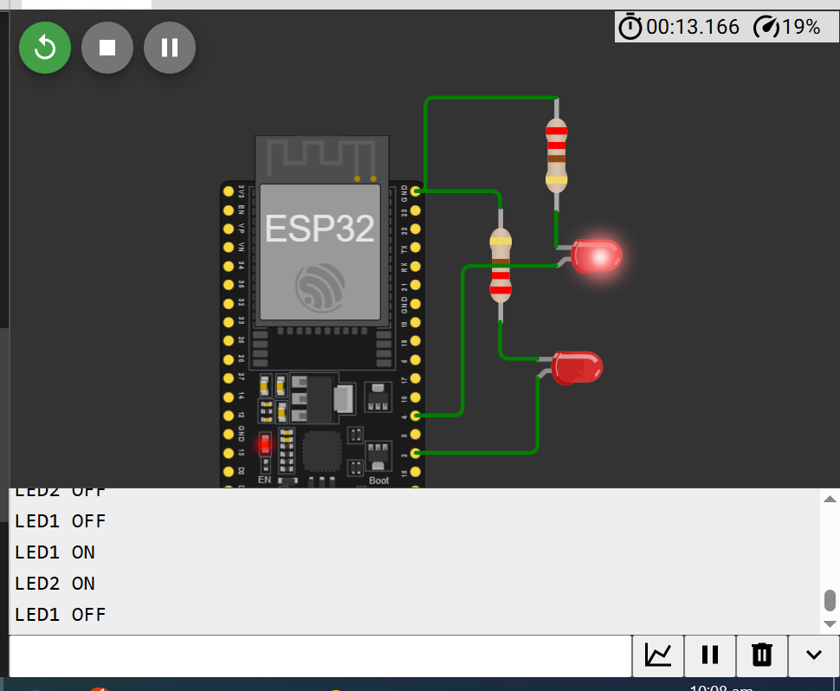

Connections:
- Connect LED1 to pin 13 through a resistor.
- Connect LED2 to pin 12 through a resistor.
- Connect the board to the computer using USB cable.

Algorithm:
- Initialize both LED pins as outputs.
- Create Task 1 for LED1 blinking every 500 ms.
- Create Task 2 for LED2 blinking every 1000 ms.
- Assign different priorities to tasks.
- Start the scheduler.
- Both LEDs blink independently.

Result
LED1 blinked every 500 ms while LED2 blinked every 1000 ms. Both tasks executed independently with different priorities.
--------------------------------------------------------------

Task 03:
Task Priority demonstration.
Create:
High priority task
Low priority task

High Priority task execute more often.

Procedure:
- Open Arduino IDE.
- Write the program for task priorities.
- Upload the code.
- Open Serial Monitor.
- Observe task execution frequency.

Code:
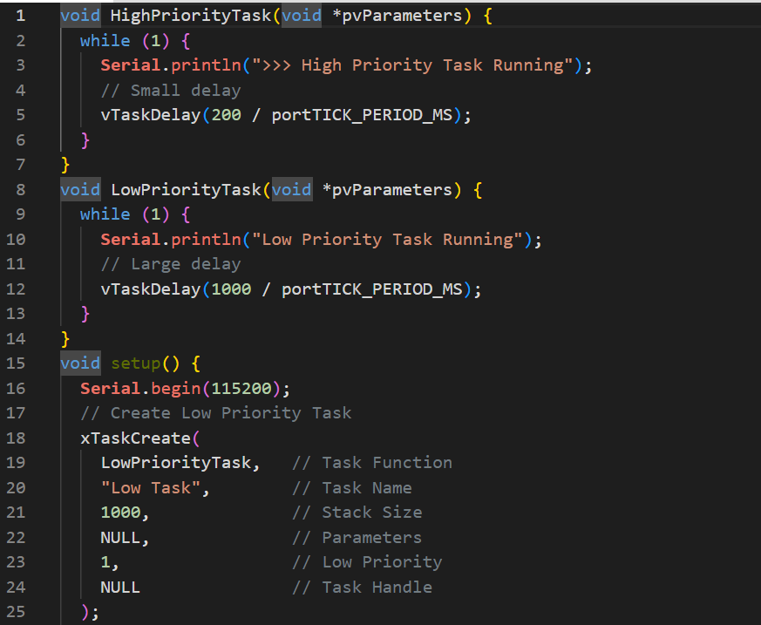

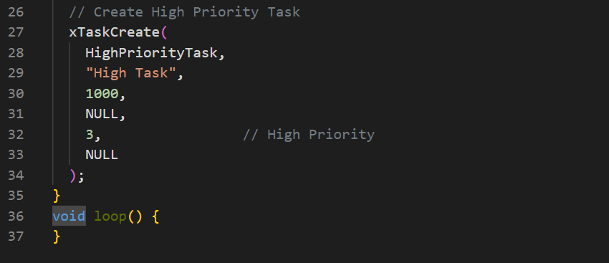

Circuit and Output:
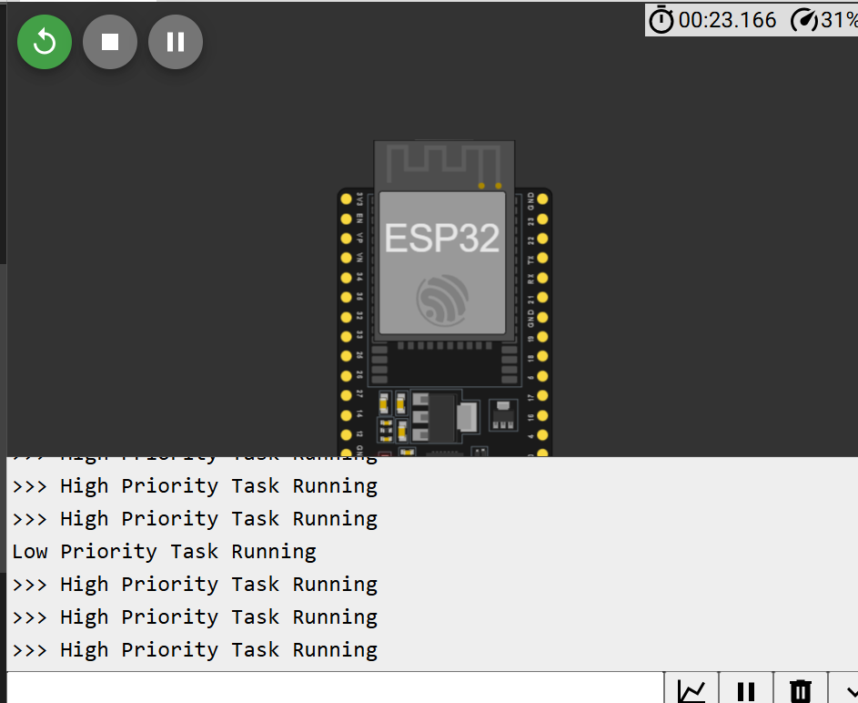

Connections:
- Connect the board to the computer using USB cable.
- Use Serial Monitor to display task execution.

Algorithm:
- Create a high priority task.
- Create a low priority task.
- Print messages from both tasks.
- Assign higher priority to one task.
- Start scheduler.
- Observe execution behavior.

Result:
The high priority task executed more frequently than the low priority task. This demonstrated how RTOS handles task priorities efficiently.

Conclusion:
In this lab, we learned the fundamentals of RTOS and FreeRTOS. Different tasks were created and executed independently using multitasking. We also learned task scheduling, task priorities, and efficient CPU management in embedded systems. The lab successfully demonstrated how RTOS improves system performance and responsiveness.

________________________________END_____________________________

